|  |
| --- |
| **(Autonomous Institute, Affiliated to VTU)**  **Department of Information Science and Engineering** |
|  |
| A Mini Project Report on |
| **“SPAM E-MAIL CLASSIFIER”** |
| *Submitted in partial fulfillment of the CIE for the subject*  **Natural Language Processing(ISE552)** |
| by |
| **MOHANKUMAR K (1MS18IS053)**  **NAGARAJ U (1MS18IS054)**  **NITIN C KALLAPPA (1MS18IS060)** |
|  |
|  |
| *Under the guidance*  *of* |
| **Ms. Rajeshwari S B** |
| Assistant Professor |
| Department of ISE, MSRIT |
| Bengaluru-560054 |

**TABLE OF CONTENTS**

|  |  |  |
| --- | --- | --- |
| **1.** | **INTRODUCTION** | **3** |
| **2.** | **PROBLEM STATEMENT** | **5** |
| **3.** | **SOURCE CODE** | **7** |
| **4.** | **TESTING, RESULTS AND DISCUSSION** | **22** |
| **5.** | **CONCLUSION AND FUTURE WORK** | **26** |
| **6.** | **REFERENCES** | **27** |
|  |  |  |

INTRODUCTION

Electronic spamming is the use of electronic messaging systems to send an unsolicited message (spam), especially advertising, as well as sending messages repeatedly on the same site. While the most widely recognized form of spam is email spam, the term is applied to similar abuses in other media: instant messaging spam, Usenet newsgroup spam, Web search engine spam, spam in blogs, wiki spam, online classified ads spam, mobile phone messaging spam, Internet forum spam, junk fax transmissions, social spam, spam mobile apps, television advertising and file sharing spam.The source and identity of the sender is anonymous and there is no option to cease receiving future e-mails. Span e-mail is usually sent by spam bot, which is program that continually sends out email. Often spammers will create a virus that install a spam bot into unsuspecting users computers and will use there internet connection and computer to send spam.

Spam e-mail are message randomly sent to multiple addressees by all sorts of groups, but mostly lazy advertisers and criminals who wish to lead you to phishing sites. The sites attempt to steal your personal, electronic, and financial information.

Bayesian Spam Detection/ Filtering is used to detect spam in an email. A Bayesian network is a representation of probabilistic relationships. This paper will show that Bayesian filtering can be simply implemented for a reasonably accurate text classifier and that it can be modified to make a significant impact on the accuracy of the filter.

Major approaches adopted towards spam filtering include text analysis, white and black lists of domain names and community based approaches. Text analysis of contents of mails is a widely used approach towards the spams. Many solutions deployable on server and client sides are available. Naive Bayes is one of the most popular algorithms used in these approaches. Spam Bayes and Mozilla Mail spam filter are examples of such solutions. But rejecting mails based on text analysis can be serious problem in case of false positives. Normally users and organizations would not want any genuine e-mails to be lost. Black list approach has been one of the earliest approaches tried for the filtering of spams. The strategy is to accept all the mails except the ones from the domain/e-mail ids. Explicitly blacklisted. With newer domains entering the category of spamming domains this strategy tends to not work so well. White list approach is the strategy of accepting the mails from the domains/addresses explicitly white listed and put others in a less priority queue, which is delivered only after sender responds to a confirmation request sent by the spam filtering system.

PROBLEM STATEMENT

Spamming is one of the major attacks that accumulate the large number of compromised machines by sending unwanted messages, viruses and phishing through emails. We have chosen this project because now days there are lot of people trying to fool you just by sending you fake e-mails like you have won 1000 dollars, this much amount is deposited in your account once you open this link then they will track you and try to hack your information. Sometimes relevant e-mails are considered as spam emails.

• Unwanted email irritating Internet consumers.

• Critical email messages are missed and/or delayed.

• Consumers change ISP's all the time looking for consistent email delivery.

• Loss of Internet performance and bandwidth.

• Millions of compromised computers.

• Billions of dollars lost worldwide.

• Identity Theft.

• Increase in Worms and Trojan Horses.

• Spam can crash mail servers and fill up hard drive

BAYE’S THEOREM

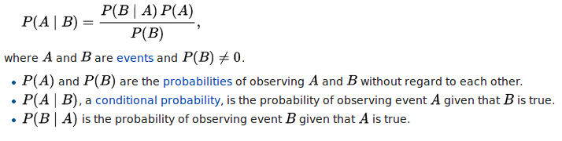

We have a message m = (w*1*, w*2*, . . . . , w*n*), where (w*1*, w*2*, . . . . , w*n*) is a set of unique words contained in the message. We need to find

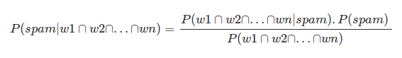

If we assume that occurrence of a word are independent of all other words, we can simplify the above expression to

Image for post

In order to classify we have to determine which is greater

Image for post

SOURCE CODE

1.PRE-PROCESSING

#PRE PROCESSING

from os import walk

from os.path import join

import pandas as pd

import time

import numpy as np

import matplotlib.pyplot as plt

%matplotlib inline

import nltk

from nltk.stem import PorterStemmer

from nltk.tokenize import word_tokenize

from nltk.corpus import stopwords

from sklearn.model_selection import train_test_split

from bs4 import BeautifulSoup

from wordcloud import WordCloud

from PIL import Image

EXAMPLE_FILE = 'SpamData/01_Processing/practice_email.txt'

SPAM_1_PATH = 'SpamData/01_Processing/spam_assassin_corpus/spam_1'

SPAM_2_PATH = 'SpamData/01_Processing/spam_assassin_corpus/spam_2'

NONSPAM_1_PATH = 'SpamData/01_Processing/spam_assassin_corpus/easy_ham_1'

NONSPAM_2_PATH = 'SpamData/01_Processing/spam_assassin_corpus/easy_ham_2'

EMAIL_TEXT_JSON_PATH = 'SpamData/01_Processing/email-text.json'

WORD_ID_FILE = 'SpamData/01_Processing/word-by-id.csv'

SPAM_CAT = 1

NONSPAM_CAT = 0

VOCABULARY_SIZE = 2500

TRAINING_DATA = 'SpamData/02_Training/train-data.txt'

TESTING_DATA = 'SpamData/02_Training/test-data.txt'

WHALE_FILE = 'SpamData/01_Processing/wordcloud_resources/whale-icon.png'

SKULL_FILE = 'SpamData/01_Processing/wordcloud_resources/skull-icon.png'

THUMBS_UP_FILE = 'SpamData/01_Processing/wordcloud_resources/thumbs-up.png'

THUMBS_DOWN_FILE = 'SpamData/01_Processing/wordcloud_resources/thumbs-down.png'

CUSTOM_FONT_FILE = 'SpamData/01_Processing/wordcloud_resources/OpenSansCondensed-Bold.ttf'

def get_email_body(path):

for root, dirname, filenames in walk(path):

for file_name in filenames:

filepath = join(root,file_name)

stream = open(filepath, encoding='latin_1')

is_body = False

lines = []

for line in stream:

if is_body:

lines.append(line)

elif line == '\n':

is_body=True

stream.close()

email_body = '\n'.join(lines)

yield file_name, email_body

def dataframe_from_directory(path,classification):

rows = []

rows_name = []

for file_name, email_body in get_email_body(path):

rows.append({'MESSAGE' : email_body, 'CATEGORY' : classification})

rows_name.append(file_name)

return pd.DataFrame(rows,index=rows_name)

spam_emails.shape

non_spam_emails = dataframe_from_directory(NONSPAM_1_PATH,NONSPAM_CAT)

non_spam_emails = non_spam_emails.append(dataframe_from_directory(NONSPAM_2_PATH,NONSPAM_CAT))

print(non_spam_emails.shape)

non_spam_emails.head()

data = pd.concat([spam_emails,non_spam_emails])

print(f' shape of entire dataframe is {data.shape}')

document_ids = range(0,len(data.index))

data['DOC_ID'] = document_ids # column to hold index 0-5796

data['FILE_NAME'] = data.index #creating separate column to hold original file names

data.set_index('DOC_ID',inplace=True) #changing index from filenales to DOC_ID

data.head()

data.to_json(EMAIL_TEXT_JSON_PATH)

data['CATEGORY'].value_counts()

amount_of_spam = data['CATEGORY'].value_counts()[1]

amount_of_ham = data['CATEGORY'].value_counts()[0]

category_names = ['spam' , 'legit emails']

sizes = [amount_of_spam ,amount_of_ham]

chart_colors = ['#b2ebf2','#e97171']

plt.figure(figsize=(6,6),dpi = 100) # dpi: density of pixels per inch

plt.pie(sizes ,labels=category_names,textprops={'fontsize' : 14} ,startangle=90,colors=chart_colors,explode=[0,0.1],

autopct='%1.0f%%')

plt.show()

#NLP

nltk.download('punkt')

stop_words = set(stopwords.words('english')) #removing stopwords

stopwords

def clean_messages_no_html(message , stemmer = PorterStemmer()

,stop_words = set(stopwords.words('english'))):

filtered_words = []

soup = BeautifulSoup(message , 'html.parser')

cleaned_text = soup.get_text()

words = word_tokenize(cleaned_text.lower())

for word in words:

if word not in stop_words and word.isalpha(): #checking word in stopwords ? and removing punctuation

filtered_words.append(stemmer.stem(word)) #stemming word

return filtered_words

data[data['CATEGORY'] == 1].shape

data[data['CATEGORY'] == 0].shape

doc_ids_ham = data[data['CATEGORY'] == 0].index

doc_ids_spam = data[data['CATEGORY'] == 1].index

%%time

nested_list = data['MESSAGE'].apply(clean_messages_no_html) #List of lists

nested_list.head()

nested_list_spam = nested_list.loc[doc_ids_spam]

nested_list_ham = nested_list.loc[doc_ids_ham]

print(type(nested_list_ham))

flat_list_spam = []

flat_list_ham = []

for sublist in nested_list_spam:

for word in sublist:

flat_list_spam.append(word)

for sublist in nested_list_ham:

for word in sublist:

flat_list_ham.append(word)

print(type(flat_list_ham))

# Converting list to pandas series

normal_words = pd.Series(flat_list_ham).value_counts()

# print(f'total number of normal words : {normal_words.shape[0]}')

print(f'total number of unique normal words : {normal_words.shape[0]}')

spammy_words = pd.Series(flat_list_spam).value_counts() # value_counts() holds only unique words

# print(f'total number of spammy words : {spammy_words.shape[0]}')

print(f'total number of unique spammy words : {spammy_words.shape[0]}')

print(f'Most used normal words: \n\n{normal_words[:10]}\n')

print(f'\nMost used spammy words: \n\n{spammy_words[:10]}\n')

# Generating text as string for spam messages

spam_str = ' '.join(flat_list_spam)

icon = Image.open(THUMBS_UP_FILE)

image_mask = Image.new(mode='RGB',size=icon.size,color=(255,255,255))

image_mask.paste(icon,box=icon)

rgb_array = np.array(image_mask)

word_cloud = WordCloud(mask=rgb_array,max_words=2000,background_color='white',max_font_size=300,

colormap='gist_heat',font_path=CUSTOM_FONT_FILE)

word_cloud.generate(spam_str.upper())

plt.figure(figsize=(16,8))

plt.imshow(word_cloud,interpolation='bilinear')

plt.axis('off')

plt.show()

# Generating text as string for ham messages

ham_str = ' '.join(flat_list_ham)

icon = Image.open(THUMBS_DOWN_FILE)

image_mask = Image.new(mode='RGB',size=icon.size,color=(255,255,255))

image_mask.paste(icon,box=icon)

rgb_array = np.array(image_mask)

word_cloud = WordCloud(mask=rgb_array,max_words=2000,background_color='white',max_font_size=300,

colormap='gist_heat',font_path=CUSTOM_FONT_FILE)

word_cloud.generate(ham_str.upper())

plt.figure(figsize=(16,8))

plt.imshow(word_cloud,interpolation='bilinear')

plt.axis('off')

plt.show()

stemmed_nested_list = data['MESSAGE'].apply(clean_messages_no_html) # nested list of words in each emails bodies

flat_stemmed_list = [item for sublist in stemmed_nested_list for item in sublist]

unique_words = pd.Series(flat_stemmed_list).value_counts()

print(f' Total number of unique words : {unique_words.shape[0]}')

unique_words.head()

frequent_words = unique_words[0:VOCABULARY_SIZE]

print( f'Most 10 frequently used words : \n {frequent_words[0:10]}')

word_ids = list(range(0,VOCABULARY_SIZE))

vocab = pd.DataFrame({'VOCAB_WORD':frequent_words.index.values})

print(type(vocab))

vocab.index.name= 'WORD_ID'

vocab.head()

vocab.to_csv(WORD_ID_FILE,index_label=vocab.index.name,header=vocab['VOCAB_WORD'].name)

print(stemmed_nested_list)

word_column_df = pd.DataFrame.from_records(stemmed_nested_list.to_list())

word_column_df.head()# converting pandas series to list of list

word_column_df.shape

X_train,X_test,y_train,y_test = train_test_split(word_column_df, data['CATEGORY'], test_size = 0.3, random_state = 42)

X_train.index.name = X_test.index.name = 'DOC_ID'

X_train.head()

y_train.head()

word_index = pd.Index(vocab['VOCAB_WORD'])

print(type(word_index))

print(len(word_index))

word_index

def make_sparse_matrix(df, indexed_words, labels):

'''

returns sparse matrix as dataframe

df : A dataframe with words in the column and document_id as index (X_train , X_test)

indexed_words : index of words order by word_id

labels : category as pd series (y_train,y_test)

'''

nr_rows = df.shape[0]

nr_cols = df.shape[1]

dict_list = [] # list of dictionaries

word_set = set(indexed_words)

for i in range(nr_rows):

for j in range(nr_cols):

word = df.iat[i,j]

if word in word_set:

doc_id = df.index[i]

word_id = indexed_words.get_loc(word)

category = labels.at[doc_id]

item = {'LABEL' : category , 'DOC_ID' : doc_id,'WORD_ID' : word_id,'OCCURENCE' : 1}

dict_list.append(item)

return pd.DataFrame(dict_list)

%%time

sparse_train_df= make_sparse_matrix(X_train,word_index,y_train)

sparse_train_df.head()

sparse_train_df['OCCURENCE'].isnull().any()

sparse_train_df.shape

training_grouped_data = sparse_train_df.groupby(['DOC_ID','WORD_ID','LABEL']).sum()

training_grouped_data.head()

training_grouped_data = training_grouped_data.reset_index()

training_grouped_data.head()

training_grouped_data.shape

np.savetxt(TRAINING_DATA,training_grouped_data,fmt='%d')

%%time

sparse_test_df= make_sparse_matrix(X_test,word_index,y_test)

sparse_test_df.head()

testing_grouped_data = sparse_test_df.groupby(['DOC_ID','WORD_ID','LABEL']).sum().reset_index()

np.savetxt(TESTING_DATA,testing_grouped_data,fmt='%d')

testing_grouped_data.columns

sparse_test_df.shape

2.TRAINING

import numpy as np

import pandas as pd

VOCABULARY_SIZE = 2500

TRAINING_DATA = 'SpamData/02_Training/train-data.txt'

TESTING_DATA = 'SpamData/02_Training/test-data.txt'

TEST_FEATURE_MATRIX = 'SpamData/03_Testing/test-features.txt'

TEST_TARGET_FILE = 'SpamData/03_Testing/test-target.txt'

TOKEN_SPAM_PROB_FILE = 'SpamData/03_Testing/prob-spam.txt'

TOKEN_HAM_PROB_FILE = 'SpamData/03_Testing/prob-ham.txt'

TOKEN_ALL_PROB_FILE = 'SpamData/03_Testing/prob-all-tokens.txt'

sparse_train_data = np.loadtxt(TRAINING_DATA, delimiter=' ',dtype='int')

sparse_test_data = np.loadtxt(TESTING_DATA, delimiter=' ',dtype='int')

sparse_train_data.shape

sparse_test_data.shape

sparse_train_data[:5] # columns = doc_id, word_id, category, occurence

print(f'Number of rows in training file : {sparse_train_data.shape[0]}')

print(f'Number of rows in testing file : {sparse_test_data.shape[0]}')

print(f' Number of emails in training file : {np.unique(sparse_train_data[: , 0]).size}')

print(f' Number of emails in testing file : {np.unique(sparse_test_data[: , 0]).size}')

#Creating empty dataframe

column_names = ['DOC_ID'] + ['CATEGORY'] + list(range(0 , VOCABULARY_SIZE))

column_names[:5]

len(column_names)

index_names = np.unique(sparse_train_data[:,0])

index_names

full_train_data = pd.DataFrame(index=index_names, columns=column_names)

full_train_data.head()

full_train_data.fillna(value=0,inplace=True)

#Creating Full Matrix from sparse matrix

In [16]:

def make_full_matrix(sparse_matrix, nr_words, doc_idx=0,word_idx=1,cat_idx=2,freq_idx=3):

'''

returns full matrix which contains occurences of each word in vocab in single row

sparse_matrix -- input matrix (np array)

nr_words -- size of vocabulary(2500)

doc_idx -- DOC_ID index in sparse matrix(0)

word_idx -- 'WORD_ID' index in sparse_matrix(1)

cat_idx -- 'CATEGORY' index (2)

freq_idx -- 'OCCURENCES' index (3)

'''

column_names = ['DOC_ID'] + ['CATEGORY'] + list(range(0 , VOCABULARY_SIZE))

doc_id_names = np.unique(sparse_matrix[:,0])

full_matrix = pd.DataFrame(index=doc_id_names,columns=column_names)

full_matrix.fillna(value=0,inplace=True)

for i in range(sparse_matrix.shape[0]): # iterating through all rows in sparse matrix and extracting word occurences

doc_nr = sparse_matrix[i][doc_idx] # doc_idx = 0 first column

word_id = sparse_matrix[i][word_idx]

label = sparse_matrix[i][cat_idx]

occurence = sparse_matrix[i][freq_idx]

full_matrix.at[doc_nr,'DOC_ID'] = doc_nr

full_matrix.at[doc_nr,'CATEGORY'] = label

full_matrix.at[doc_nr,word_id] = occurence

full_matrix.set_index('DOC_ID',inplace=True)

return full_matrix

%%time

full_train_data = make_full_matrix(sparse_train_data,VOCABULARY_SIZE)

full_train_data.head() # most frequent words are at begining

#DOC_ID : emails id of each email in dataset

#CATEGORY : wether email is spam or not 1 : spam 0 : legit

#columns 0 1 2 3 4 .......2499 indicates word_id of top 2500 words in vocabulary

#each box inside table indicates number of occurance of word in particular email

#calculating probability of spam

spam_prob = full_train_data['CATEGORY'].sum() / full_train_data['CATEGORY'].size

print(' Probability os email being spam ' ,round(spam_prob,3))

full_train_features = full_train_data.loc[:,full_train_data.columns != 'CATEGORY']

full_train_features.head() #excluding category

email_lengths = full_train_features.sum(axis=1)

email_lengths.shape

total_wordcounts = email_lengths.sum()

total_wordcounts

spam_lengths = email_lengths[full_train_data.CATEGORY == 1]

spam_lengths.shape

spam_wordcount = spam_lengths.sum()

spam_wordcount

ham_lengths = email_lengths[full_train_data.CATEGORY == 0]

ham_lengths.shape

ham_wordcount = ham_lengths.sum()

ham_wordcount

print(f'Avg number of words in spam emails : {spam_wordcount / spam_lengths.shape[0]}')

print(f'Avg number of words in ham emails : {ham_wordcount / ham_lengths.shape[0]}')

#Summing the Tokens Occuring in spam

full_train_features.shape

train_spam_tokens = full_train_features.loc[full_train_data.CATEGORY == 1]

train_spam_tokens.head()

# Calculating number of time each word appeared in all spam emails

summed_spam_tokens = train_spam_tokens.sum(axis=0) + 1 # +1 to avoid zero by error while calculating probability

summed_spam_tokens.shape # axis = 0 to sum columns

summed_spam_tokens.head()

#Summing tokens occuring in ham emails

train_ham_tokens = full_train_features.loc[full_train_data.CATEGORY == 0]

train_ham_tokens.head()

# Calculating number of time each word appeared in all ham emails

summed_ham_tokens = train_ham_tokens.sum(axis=0) + 1 # +1 to avoid zero by error while calculating probability

summed_ham_tokens.shape # axis = 0 to sum columns

#p( token | spam ) : Probabilty that token ocuurs given email is spam

prob_tokens_spam = summed_spam_tokens / (spam_wordcount + VOCABULARY_SIZE) #devide by VOCABULARY_SIZE coz we added 1 to

#summed_spam tokens

prob_tokens_spam[:5]

prob_tokens_spam.sum()

#p( token | nonspam ) : Probabilty that token ocuurs given email is non-spam

prob_tokens_ham = summed_ham_tokens / (ham_wordcount + VOCABULARY_SIZE)

prob_tokens_ham.sum()

prob_token_all = full_train_features.sum(axis=0) / total_wordcounts

prob_token_all

#Saving trained model

np.savetxt(TOKEN_SPAM_PROB_FILE,prob_tokens_spam)

np.savetxt(TOKEN_HAM_PROB_FILE,prob_tokens_ham)

np.savetxt(TOKEN_ALL_PROB_FILE,prob_token_all)

#Prepare test data

sparse_test_data.shape

%%time

full_test_data = make_full_matrix(sparse_test_data,nr_words=VOCABULARY_SIZE)

X_test = full_test_data.loc[:, full_test_data.columns != 'CATEGORY']

y_test = full_test_data.CATEGORY

X_test.shape

np.savetxt(TEST_TARGET_FILE,y_test)

np.savetxt(TEST_FEATURE_MATRIX,X_test)

3.TESTING

import numpy as np

import pandas as pd

import seaborn as sns

import matplotlib.pyplot as plt

VOCABULARY_SIZE = 2500

TEST_FEATURE_MATRIX = 'SpamData/03_Testing/test-features.txt'

TEST_TARGET_FILE = 'SpamData/03_Testing/test-target.txt'

TOKEN_SPAM_PROB_FILE = 'SpamData/03_Testing/prob-spam.txt'

TOKEN_HAM_PROB_FILE = 'SpamData/03_Testing/prob-ham.txt'

TOKEN_ALL_PROB_FILE = 'SpamData/03_Testing/prob-all-tokens.txt'

#features

X_test = np.loadtxt(TEST_FEATURE_MATRIX,delimiter=' ')

#target

y_test = np.loadtxt(TEST_TARGET_FILE,delimiter=' ')

#token probabilities

prob_token_spam = np.loadtxt(TOKEN_SPAM_PROB_FILE,delimiter=' ')

prob_token_ham = np.loadtxt(TOKEN_HAM_PROB_FILE,delimiter=' ')

prob_all_tokens = np.loadtxt(TOKEN_ALL_PROB_FILE,delimiter=' ')

X_test.shape

y_test.shape

print(f' shape of dot product is : {X_test.dot(prob_token_spam).shape}')

shape of dot product is : (1724,)

#Set the prior

P(spam \, | \, X ) = \frac{ \, P(X \, | \, spam \,) \, p(spam \,)} { P(X) }

PROB_SPAM = 0.311

# Taking log to make it easier for calculations

# P(spam|X) = p(X|spam)*p(spam)/p(X) can be written as P(spam|X) = log(p(X|spam)) + log(p(spam)) - log(p(X))

np.log(prob_token_spam)

# calculating probablity of emails being spam for all testing dataset based on values we got fron training model

joint_log_spam = X_test.dot(np.log(prob_token_spam) - np.log(prob_all_tokens)) + np.log(PROB_SPAM)

joint_log_spam[:5]

# calculating probablity of emails being non-spam for all testing dataset based on values we got fron training model

joint_log_ham = X_test.dot(np.log(prob_token_ham) - np.log(prob_all_tokens)) + np.log(1-PROB_SPAM)

joint_log_ham[:5]

joint_log_ham.size

joint_log_spam.size

checking for higher joint probability

$$ P(Spam \, | \, X \,) &gt; P(Ham \, | X ) $$

predictions = joint_log_spam > joint_log_ham

predictions[-8:] * 1

y_test[-8:]

predictions.shape

predictions[1333]

y_test[1333]

predictions[980]

y_test[980]

predictions[2]

y_test[2]

predicted_result = []

actual_result = []

num = 100

for i in range(10):

predicted_result.append(predictions[num])

actual_result.append(y_test[num])

num += 1

print(predicted_result)

print(actual_result)

[True, True, True, True, True, True, True, False, True, True]

[1.0, 1.0, 1.0, 1.0, 1.0, 1.0, 1.0, 1.0, 1.0, 1.0]

Simplifying

Removing denominator P(X) as we are deviding that to both spam and ham emails so P(spam|X) > P(ham|X) remain uneffected

joint_log_spam = X_test.dot(np.log(prob_token_spam)) + np.log(PROB_SPAM)

joint_log_ham = X_test.dot(np.log(prob_token_ham)) + np.log(1-PROB_SPAM)

predictions = joint_log_spam > joint_log_ham

# output 1 : spam email 0 : legit email

def compare_results(index):

predicted = predictions[index] * 1

actual = y_test[index]

print("predicted value = " ,predicted)

print("actual value = " ,actual)

if(predicted == actual):

print("model predicted correctly")

else:

print("model predicted wrongly")

compare_results(1680);

compare_results(790);

compare_results(1719);

compare_results(1500);

predicted value = 0

actual value = 0.0

model predicted correctly

predicted value = 0

actual value = 0.0

model predicted correctly

predicted value = 1

actual value = 0.0

model predicted wrongly

predicted value = 0

actual value = 0.0

model predicted correctly

# Getting results for consecutive 10 mails

def get_results1(index):

predicted_result = []

actual_result = []

for i in range(10):

predicted_result.append(predictions[index])

actual_result.append(y_test[index])

index += 1

print(predicted_result)

print(actual_result)

get_results1(1714)

[False, False, False, False, False, True, False, False, False, False]

[0.0, 0.0, 0.0, 0.0, 0.0, 0.0, 0.0, 0.0, 0.0, 0.0]

Metrics and Accuracy

#Accuracy

nr_correct_predictions = (y_test == predictions).sum()

print(f'Number of emails classified correctly are : {nr_correct_predictions}')

nr_wrong_predictions = X_test.shape[0] - nr_correct_predictions

print(f'Number of wrong predictions : {nr_wrong_predictions}')

#Number of emails classified correctly are : 1685

#Number of wrong predictions : 39

y_test[(y_test != predictions)]

predictions[(y_test != predictions)]

accuracy = nr_correct_predictions/len(X_test) * 100

print(f' Accuracy of model is : {round(accuracy,2)}%')

Accuracy of model is : 97.74%

frac_wrong = nr_wrong_predictions/len(X_test) * 100

print(f'Fraction of wrong predictions : {round(frac_wrong,2)}%')

#Fraction of wrong predictions : 2.26%

Visualising the results

# Chart styling info

xaxis_label = 'P(Non-Spam | X)'

yaxis_label = 'P(Spam | X)'

plt.figure(figsize=(12,7))

plt.xlabel(xaxis_label,fontsize = 14)

plt.ylabel(yaxis_label,fontsize=14)

#Set limits

plt.xlim([-14000,1])

plt.ylim([-14000,1])

plt.scatter(joint_log_ham,joint_log_spam,color='navy')

plt.show()

# Chart styling info

xaxis_label = 'P(Non-Spam | X)'

yaxis_label = 'P(Spam | X)'

linedata = np.linspace(start=-14000,stop=1,num=1000)

plt.figure(figsize=(12,7))

plt.xlabel(xaxis_label,fontsize = 14)

plt.ylabel(yaxis_label,fontsize=14)

#Set limits

plt.xlim([-14000,1])

plt.ylim([-14000,1])

plt.scatter(joint_log_ham,joint_log_spam,color='navy',alpha=0.5,s=25)

plt.plot(linedata,linedata,color='orange')

plt.show()

# Chart styling info

xaxis_label = 'P(Non-Spam | X)'

yaxis_label = 'P(Spam | X)'

linedata = np.linspace(start=-14000,stop=1,num=1000) # for plotting diagonal line

plt.figure(figsize=(18,7))

#CREATING TWO SEPARATE CHARTS SIDE BY SIDE

#Chart number : 1

plt.subplot(1,2,1) # 1:rows 2:columns 1:index

plt.xlabel(xaxis_label,fontsize = 14)

plt.ylabel(yaxis_label,fontsize=14)

#Set limits

plt.xlim([-14000,1])

plt.ylim([-14000,1])

plt.scatter(joint_log_ham,joint_log_spam,color='navy',alpha=0.5,s=25)

plt.plot(linedata,linedata,color='orange')

#Chart number : 2

plt.subplot(1,2,2)

plt.xlabel(xaxis_label,fontsize = 14)

plt.ylabel(yaxis_label,fontsize=14)

#Set limits

plt.xlim([-2000,1]) # reducing limits to get clear scatters

plt.ylim([-2000,1])

plt.scatter(joint_log_ham,joint_log_spam,color='navy',alpha=0.5,s=5)

plt.plot(linedata,linedata,color='red')

plt.show()

sns.set_style='whitegrid'

labels = 'Actual category'

#creating DF with xaxis_label : column names for ham probs , yaxis_label : column names for spam, labels :column name for labels

summary_df = pd.DataFrame({xaxis_label : joint_log_ham,yaxis_label : joint_log_spam, labels : y_test}) #concatinating all three

sns.lmplot(x=xaxis_label,y=yaxis_label,data=summary_df, size=7,fit_reg=False,

scatter_kws={'alpha': 0.5 , 's' : 25},hue=labels)

plt.xlim([-2000,1]) # reducing limits to get clear scatters

plt.ylim([-2000,1])

plt.plot(linedata,linedata,color='black')

plt.legend(('Decision boundary','non-spam','spam'),loc='lower right',fontsize=14)

plt.show()

#False positives and False negatives

np.unique(predictions,return_counts=True) # 1136 : ham 588 : spam ; according to model

true_positives = (predictions == 1) & (y_test == 1)

true_positives.sum()

true_negatives = (predictions == 0) & (y_test == 0)

true_negatives.sum()

false_positives = (predictions == 1) & (y_test == 0)

false_positives.sum()

false_negatives = (predictions == 0) & (y_test == 1)

false_negatives.sum()

e[0]

#Recall score

recall-score = true positives / (true positives + false negatives)

recall_score = true_positives.sum()/(true_positives.sum() + false_negatives.sum())

recall_score

print(f'Recall score is : {round((recall_score),4) * 100}% ')

Recall score is : 96.6%

# Precision

precision = true_positives / (true_positives + false_positives)

In [132]:

precision = true_positives.sum()/(true_positives.sum() + false_positives.sum())

precision

print(f'Precision is : {round((precision),4) * 100}% ')

#Precision is : 96.77%

F-score (combining precision and recall score to get max value)Â¶

f_score = 2 * (precision * recall_score)/(precision + recall_score)

print(f'F score is : {round(f_score,4) * 100}')

F score is : 96.69

TESTING,RESULTS AND DISCUSSION

In order to create algorithm for this, we need to teach our program what a spam email looks like and what non-spam emails look like. . We also need a way to test the accuracy of our spam filter. One idea would be to test it on the same data that we used for training. However, this can lead to a major problem in ML called overfitting which means that our model is too biased towards the training data and may not work as well on elements outside of that training set. One common way to avoid this is to split our labeled data for training/testing. This ensures we test on different data than we trained on. It’s important to note that we need a mix of both spam and non-spam data in our data sets, not just the spam ones. We really want our training data to be as similar to real email data as possible.

Some of the testing cases and predictions are showed below

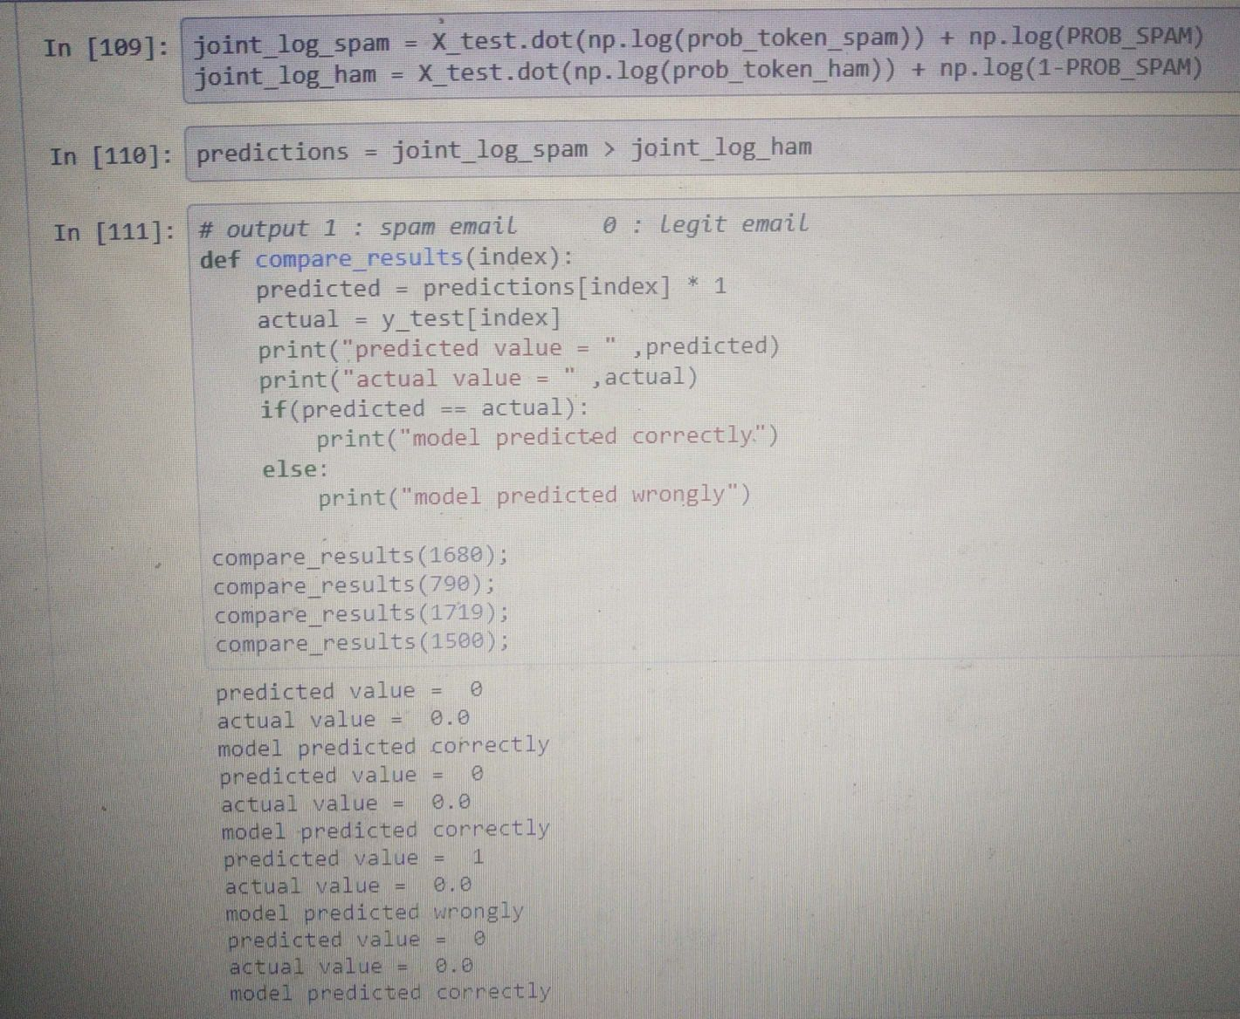

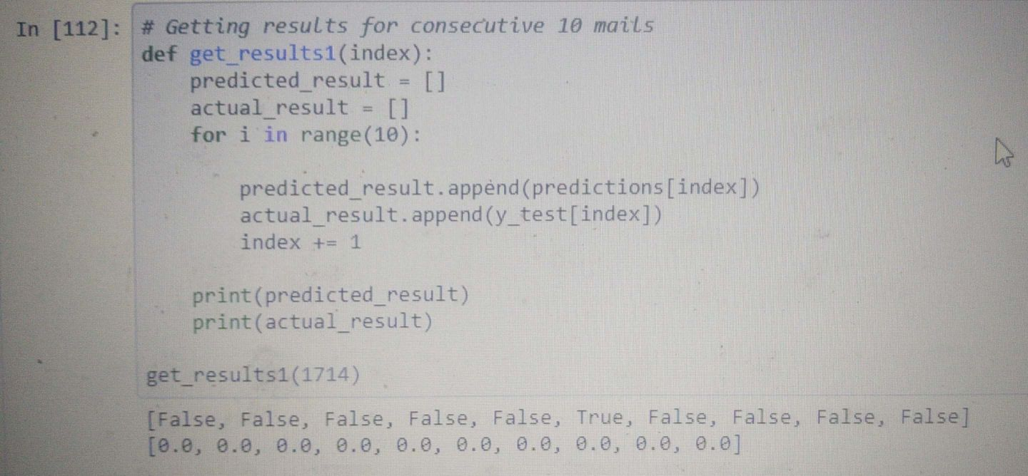

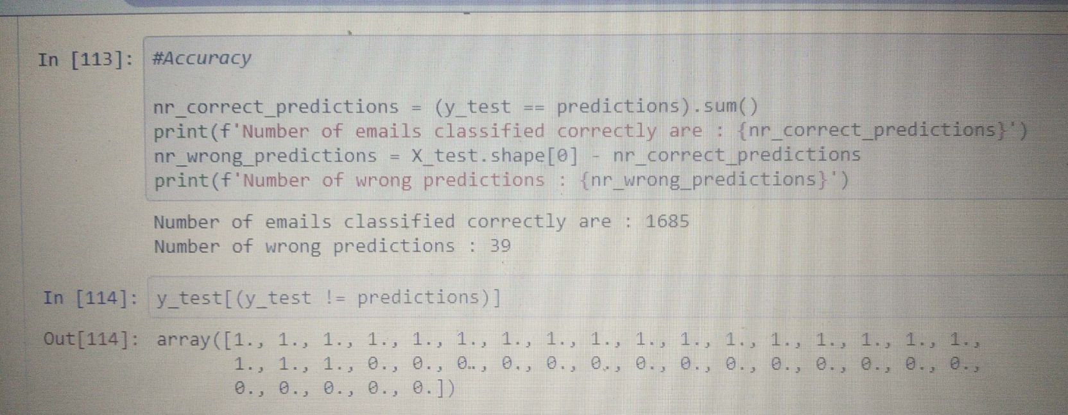

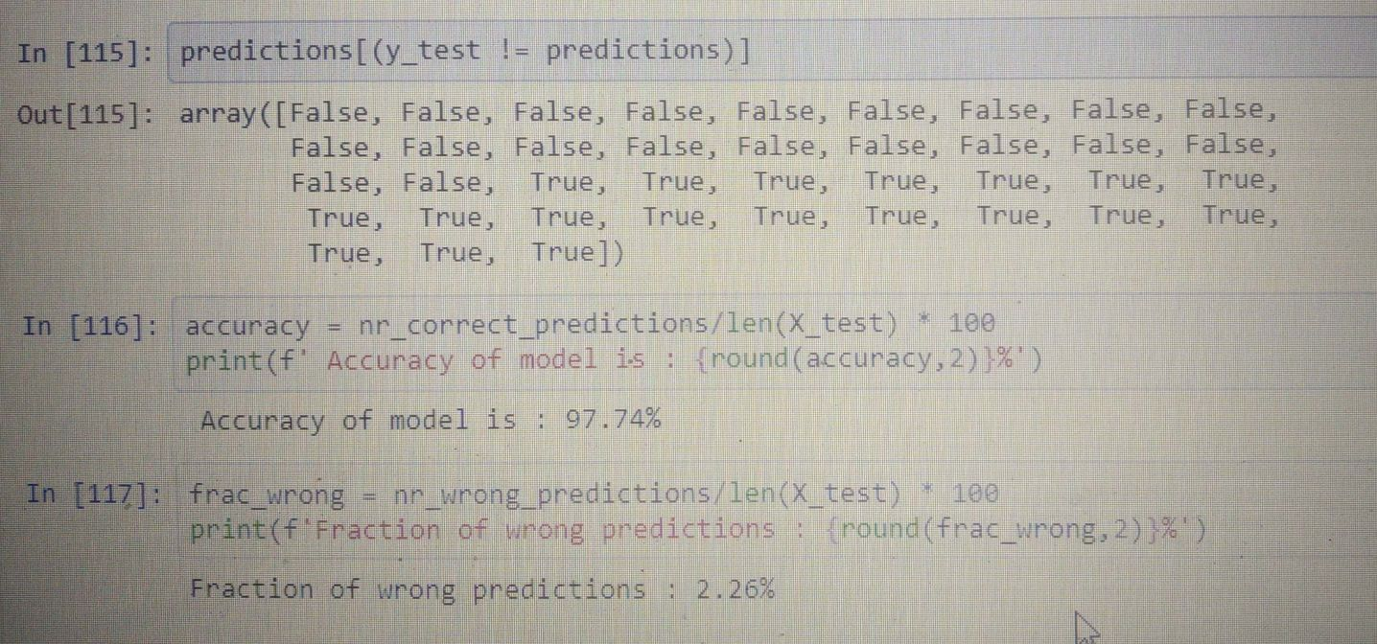

Some of the graphs and visualization areas from our projects are listed below.

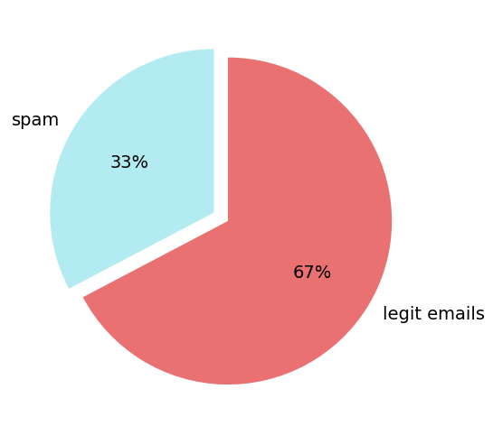

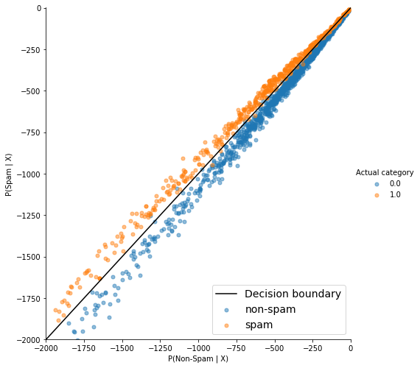

CONCLUSION AND FUTURE WORK

We are able to classify the emails as spam or non-spam. With high number of emails lots if people using the system it will be difficult to handle all possible mails as our project deals with only limited amount of corpus.

There is a wide scope of enhancement in our project. Following enhancements can be done: Filtering of spams can be done on the basis of its contents. The spam email classification is very important in classifying e-mails and to separate e-mails that are spam or non-spam. This method can be used by big organization to distinguish good mails that is only the mails they wish to receive.

REFERENCES

<https://github.com/Nagaraj-U/NLP-Mini-Project-Email-Spam-Classifier>

<https://towardsdatascience.com/spam-classifier-in-python-from-scratch-27a98ddd8e73>